ATOMIC STRUCTURE

Bohr Model of the Atom

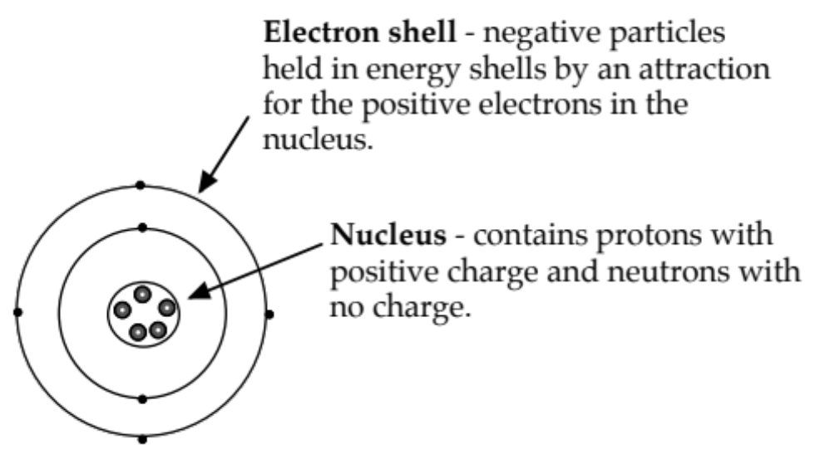

Element- contains only one type of atom.

Compound - two or more elements chemically combined in fixed proportions.

Molecule - two or more atoms chemically combined.

Energy Shells - electrons are found in distinct energy shells around the nucleus.

Each of the energy shells has a maximum number of electrons that can be held.

WE WILL CONSIDER THE FIRST 20 ELEMENTS ONLY.

1st shell 2
The arrangement of electrons in the shells is called the electron configuration for the element.
2nd shell 8
3rd shell 8
4th shell 2

Drawings - Year 10 Work

It is possible to draw diagrams to show the electron configuration of elements.
The Periodic Table is very handy for this!

Examples
